Facial key-points detection using Neural Network

Abstract :
Nowadays, facial key-points detection has become a very popular topic and it’s applications include Snapchat,How old are you, have attracted a large number of users.The objective of facial key-points detection is to find the facial key-points in given face,which is very challenging due to very different facial features from person to person.The idea of deep learning has been applied to this problem, such as neural network and cascaded neural network.
In my project, I would like to locate the key-points in a given image using deep architectures to not only obtain lower loss for the detection task but also accelerate the training and testing process for real-world applications.

Introduction :
Facial Key Points (FKPs) detection is an important and challenging problem in the field of computer vision, which involves detecting FKPs like centers and corners of eyes, nose tip, etc. The problem is to predict the (x; y) real valued co-ordinates in the space of image pixels of the FKPs for a given face image. It finds its application in tracking faces in images and videos, analysis of facial expressions, detection of dysmorphic facial signs for medical diagnosis, face recognition, etc.
There are two main challenges for facial key-points detection, one is that facial features have great variance between different people and different external factors, the other is that we have to reduce time complexity to achieve real-time key-points detection.

1. Facial features are very different :
Facial features are very different from people to people, which result in the difficulty of training the regression model. And similar as object detection task, under different illumination conditions, positions, sizes, detecting facial key-points would be very challenging.

- Detecting key-points has to be fast :
Detecting key-points in face images is one of the first few steps for many applications as we mentioned before, for example analyzing facial expression or detecting faces in images and videos. Moreover if we would like to fit the detection procedure to a real-time mobile app, we have to complete the detection within seconds. Therefore, the computation complexity of key-points detection have to be lower than traditional image classification tasks. Unlike other image classification task that we only evaluate the accuracy, we have to focus on the time that we spend on the task. When using traditional deep structures the training and testing process tend to be much slower, which is not we want for facial key-points detection.
There are two main kinds of state-of-arts methods for detecting facial key-points, the first type uses feature extraction algorithms, using Gabor features and other features, and the other one is using probability graphic model to specify the relationship between pixels and its neighbors. With the development of deep learning, many deep structures designed for this task have been explored recently. Different deep structures have been proposed for facial key-points detection, like deep convolutional cascade network , which can better deal with two main challenges we mentioned before.
In my project, I am are going to use deep structures for facial key-points detection, which can learn well from different faces and overcome the variance between faces of different person or of different conditions to a great extent. Two widely-used model, One Hidden Layer Neural Network and Convolutional Neural Network, are designed as baselines in our project. Most

importantly, we have used the pretrained Inception Model to explore some techniques to reduce the computation complexity for detecting facial key-points. With sparsely connected layers and different number of different size of filters, Inception Model have the ability to better capture local features and reduce computation complexity at the same time. When compared to our baseline models, we can see a great improvement when using pretrained inception models to predict the location of facial key-points.

The contributions of this paper includes :

1. Explore the performance of different deep structures
on the task of detecting facial key-points, and evaluate
the effectiveness using MSE loss.

2. Use the recently proposed Inception Model when detecting
facial key-points. Although the Inception Model
is trained on image classification task on Image Net,
the experiments results have shown the intermediate
features can adapted to facial key-points detection task
well.

3. Conduct experiments on real-world datasets from kaggle
challenge, and our model can be easily extended to
other facial detection task.

Related Work :
Traditional methods have explored feature extraction strategies includes texture-based and shape-based features and different types of graphic models to detect facial key-points. proposed a methods that uses Gabor wavelet feature based boosted classifiers which can detect 20 different facial key-points with limited head rotation and different illumination conditions,also use Gabor features for detecting facial key-points. Using a sample log Gabor response of a facial point, the authors have shown that the locations on the test facial images that are

similar to the sample facial points can be detected. Focused on keypoints detection for Textured 3D Face Recognition. Features are extracted by fitting a surface to the neighborhood of a keypoint and sampling it on a uniform grid. And then PCA are used for dimensional reduction and then projected and matched from a probe and gallery face. Other methods have designed probability graphic models to capture the relationship between different pixels and features to detect facial key-points. Using Markov Random Fields, exploits the constellations that facial points can form. Also the authors use boosted regression to learn the mappings from the pixels appearance of the area around the key-points and the location of the key-points. These models have reached high performance on aligned faces but still
need improvements for faces under different environment conditions.Have proposed a model to detect the target location by local evidence aggregation. By aggregating the estimates obtained from stochastically selected local appearance information into a single robust prediction other than focus only on the target location only, the proposed model have solved the regression problem from a new prospective. Recent works have focused on deep architectures for this detection task since these structures can better capture the high-level features of a image, in our problem a given face. Proposed a three-level carefully designed convolutional networks, which at first capture the global high-level features, and then refine the initiliation to locate the positions of key-points. On the other hand, used pretrained DBN on surrounding feed-forward neural network with linear Gaussian output layer to detect facial key-points. Different from our work, the deep structures mentioned before have not focused on the time complexity but only on the correctness of the detected key-points. But using Inception Model we can train a much more complexity model
in less time, thus the detection process would be faster than
the traditional deep structures considering the number of parameters, which can be adapted to this task.

Approach :
In this section, we’ll first formally formulate the key-points
detection problem and introduce performance metrics.To solve this problem, we build two models as baselines, which are realized based on simple neural network and convolutional neural network respectively. Then as the major part of this section, the Inception Model will be introduced and analyzed in detail. Especially, we’ll demonstrate its impressive advantages over traditional CNN models,and apply this model to extract low-level features as input of following networks.

Problem Formulation :
We have split our dataset into three parts 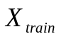, 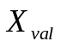,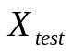 and we define the ground truth corresponding to these
three sets to be 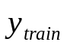, 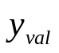,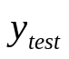.
Given a training dataset 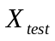we have
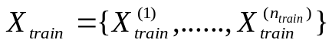

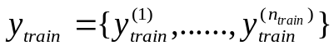

where 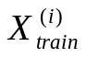 represents a given image and 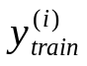 represents the key-points vector for . We will train our model M on (; 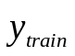) and evaluate M on (; 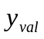) to tune parameters. After the training process, we would evaluate our model M on the test set (; 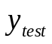).
The performance of our network models is evaluated based on two major metrics. The first one is detection accuracy, which is represented by regression loss. To be more specific, in our case, we quantize the loss using mean squared error (MSE) between the ground truth y and predicted key-points vectors ^y. The second one is time consumption in both training and testing phase.

One Hidden Layer Neural Network :
First, we use one hidden layer neural network model as
a baseline. We reshape the 96×96 image to a 9216×1 vector as the input of our network. The neuron number of the hidden layer is 100. And the output layer outputs 15 sets of coordinates of the 15 key-points, giving 30 numbers in total. The loss function is defined as the Euclidean distance between the ground truth and output key-points vectors. To converge faster, we use Nesterov momentum as the update rule for gradient

descent. The batch size is 1 and we iterate for 400 epochs during the training phase.

Convolutional Neural Network :
To achieve better key-points detection accuracy (lower loss),we build a convolution neural network model as an advanced baseline. The architecture diagram of our CNN is shown in Fig. 1. The number shown above each layer demonstrates the size of its corresponding activation, and the description below each layer describes its function. The hyper parameters of those convolutional layers in the network are illustrated in Table. 1. Both hidden layers have 500 neurons and the output layers generate a 30-element vector, same as the former one hidden layer neural network, representing the coordinates of the key-points.

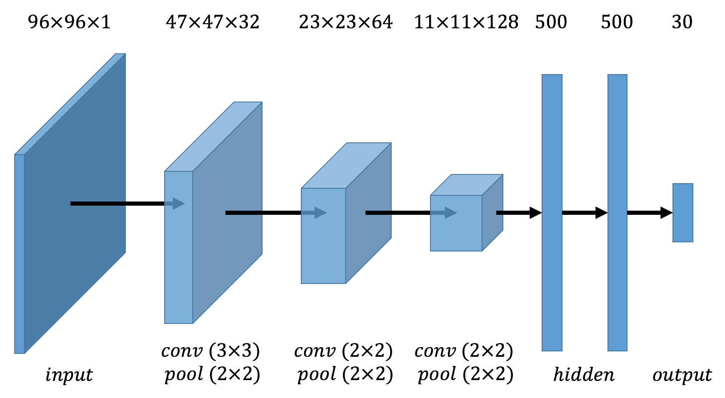
Figure 1

 | Conv layer 1 |  |  | Conv layer 2 |  |  | Conv layer 3
 | Conv | Pool | Conv |  | Pool | Conv |  | Pool
Filter | 3×3 | 2×2 | 2×2 |  | 2×2 | 2×2 |  | 2×2
Stride | 1 | 2 | 1 |  | 2 | 1 |  | 2
Pad | 0 | 0 | 0 |  | 0 | 0 |  | 0
Table 1. Hyperparameters of CNN

Insights for Baselines of Facial Key-points Detection :

As we mentioned before, one of the biggest challenges for facial key-points detection is the computation complexity. In our experiments, we find that even though CNN achieves better performance, which will be illustrated in detail in Sec. 5.3, it takes much more time to compute in each epoch (35s vs 0.30s). This

phenomenon reflects a major drawback of traditional CNN architectures that they use a dramatic amount of computational resources, especially when the network size increases. Another nature weakness of CNN is its proneness to over fitting due to its large number of parameters.

Inception Model :

As is mentioned above, one inevitable weakness of multi-layer CNN architecture is its unnecessarily large amount of parameters. Due to increased layer and parameter size, the network is inclined to overfit and fails to generalize. Besides, a huge number of parameters causes dramatically large computational resource consumption as well. To overcome such drawbacks illustrated above, one fundamental way of solving this issue is to make some ultimate adjustments from the architecture-level. Szegedy et al proposed such a model named Inception Model , which prefers sparsely connected architectures over fully connected ones, even inside the convolutions. This method not only solves the large parameter issue fundamentally, but also is more consistent from a biological perspective. However, this idea may not work as well as we expected in practice because of the optimization approach in hardware-level. When it comes to numerical computation on non-uniform sparse data structures, traditional comput-ing infrastructures are not very inefficient. This is also the reason why we need to put so many efforts in the research of efficient operations on sparse data structures, e.g. sparse matrix multiplication. In such a case, to keep the balance between computational resource consumption and computational efficiency, an optimal structure seems to be like a globally sparse convolutional neural network, which is composed of dense structures locally. Global sparsity guarantees the number of parameters is limited while local density provides efficient computation.

A typical block of the Inception Model is shown in Fig. 2. In each layer, we use multiple filters with different sizes 1×1, 3×3 and 5×5 instead of one filter in traditional CNN layers. This approach achieves so-called global sparsity since we split a huge amount of parameters from one-size filter up into several groups corresponding to different filter sizes. Meanwhile, it guarantees local density as well because each convolution operation can be realized in a traditional way.

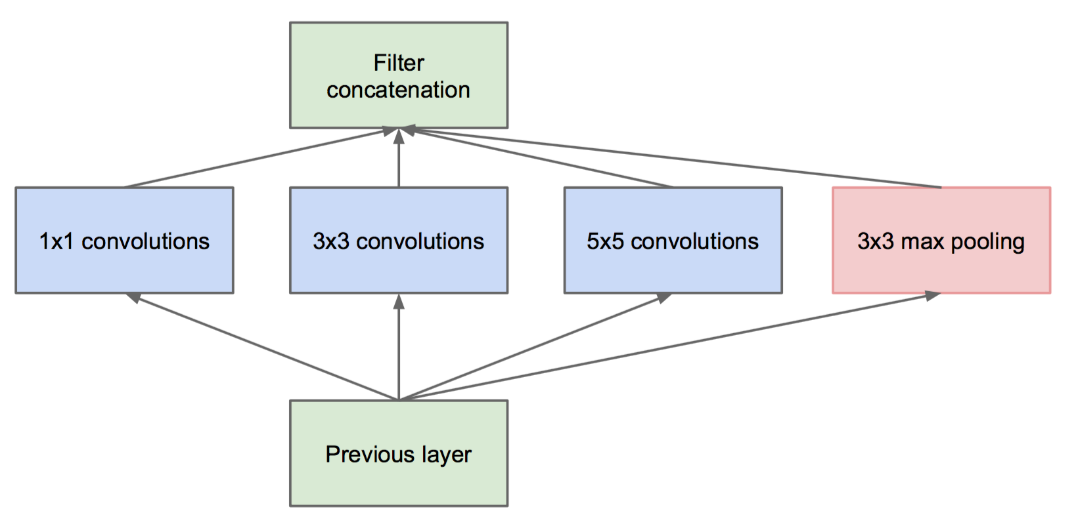
Figure 2. Naive inception module

Nevertheless, the above naive version of Inception Model block is still inefficient in computation. Assume the input size is S×S×C where S×S is the image size and C represents the channel number, then for each filter 1×1, 3×3 and 5×5, the number of channels are all the same C. A large C will lead to a large number of computations due to 5×5 filter; while if C is reduced to a moderate value, then there will be less point in using 1×1 filter since it may not generate well-generalized features. In a nutshell, this block needs further adjustments to vary the number of channels of different size filters.
To realize such an architecture illustrated above, the authors in bring up an advanced block shown in Fig. 3, which is used in the final Inception Model. The main difference from the structure in

Fig. 2 is that 1×1 convolutional filters are inserted in front of 3×3 and 5×5 filters (and after max pooling). In such a way, we first use 1×1 convolutions to compute reductions before expensive convolutions like 3×3 and 5×5. These 1×1 convolutions can also
be used as rectified linear activation's. As a result, we bear more channels when computing 3×3 and fewer for 5×5

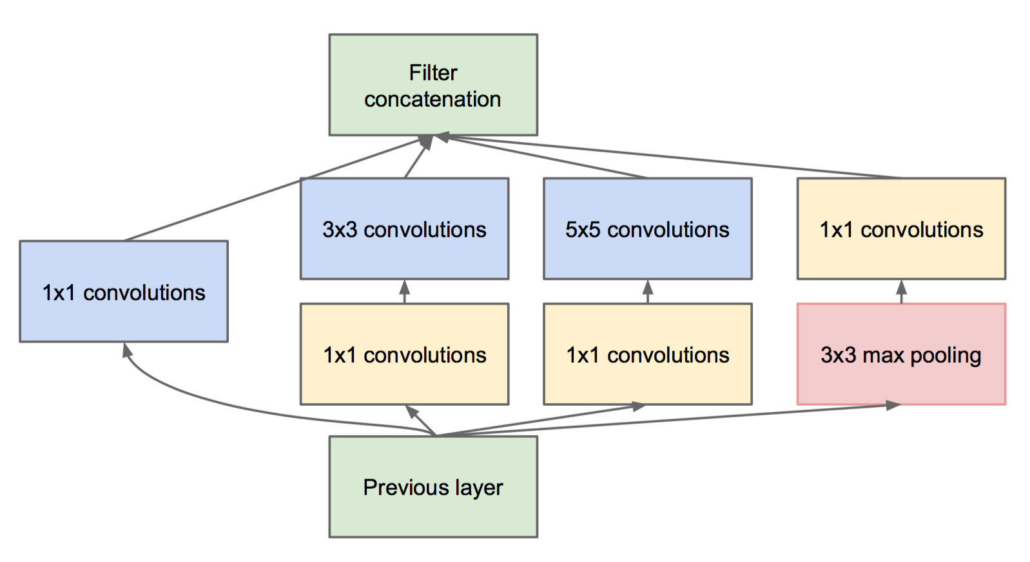
Figure 3. Inception module with dimension reductions

since it is more computationally consumptive. Here in Table. 2 displays some specific numbers of depths in each filter. The 3×3 and 5×5 reductions represent the two 1×1 convolutions inserted before them. The input depth is 128, which is reduced to 96 and 16 before 3×3 and 5×5 filters. The numbers in bold represent the
depths of convolutional outputs, which add up to 256 (= 64
+ 128 + 32 + 32) in total. Another impressive advantage of Inception Model is its flexibility to be adapted to different layers. In lower layers, which we focus more on local regions of the input

1×1 | 3×3  reduce | 3×3 | 5×5  reduce | 5×5 | Pool  Proj. | Output  Size
64 | 96 | 128 | 16 | 32 | 32 | 256
Table 2. Inception model instance

image, like edge information, what matters more is actually smaller size filters like 1 1 and 3 3. On the other hand, however,
in higher layers, where features like texture are more inclined to be captured, we probably need to use larger size filters like 5 5. Using such a model block, we can adjust the number of depths among different filters according to our demands at different layer levels. In the following experiments, we didn’t build a network
using Inception Model blocks. Instead, we extracted features from a pretrained Inception Model for image classification, and input those features to three different networks, 1) one hidden layer neural network and 2)CNN whose architectures are quite similar to the former baselines, and 3) CNN with dropout. In general, we compare performance (loss and train/test time) among those 5 networks to evaluate the effectiveness of those extracted features compared to raw image.

Dataset Description :

The dataset we use is from kaggle’s facial key-points detection
competition. There are 7049 images in total, each of which is a 96 96 pixels image. Among all the images, 2140 out of them have ground truth positions for all 15 facial key-points, which are used to as our dataset to train, validate and test the network.
The dataset is randomly divided into training set, validation
set and test set. First around 20% of all the 2140 images
are chosen to be the test set (440), where 80% of the left images
(1700) are training set (1360) and the rest of them areused for validation (340).

Experiment :

In this section, we will demonstrate how we conduct experiments
on both baseline models and inception models in

detail. First, we introduce the evaluation metrics to assess
the performance of all the models in both detection accuracy
and time complexity. Then experimental results will
be shown qualitatively and quantitatively.
5.1. Evaluation Metrics
For our experiments, as our evaluation metrics for regression
loss, we use mean squared error (MSE) between
the ground truth key-point coordinate vector and the predicted
one.
Given the ground truth 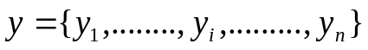 and our estimate 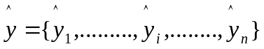, MSE loss is defined as the average of the square of all of the error, which can be represented as:

Loss MSE = 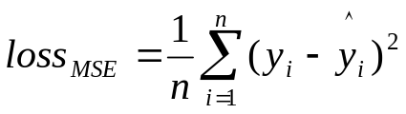

In our case, the coordinates of key-points are in the range of [0; 95][0; 95]. To better correspond to normal distribution
initialization (= 0) of weights in network, we re-scale
those coordinates to [－1,1] ×[－1,1]. As for evaluating the execution time of each model, we compare the time cost in both training phase (per epoch) and testing phase (per image).
5.2. Experimental Setup We conduct experiments on 5 models in total, 2 of which are baseline models and the left 3 are extensions from baseline using Inception Model. The experimental platform is a 2-core 2.7GHz CPU + 8GB 1867MHz memory laptop. And the framework we used for building and training CNN is Lasagne and Theano,implemented in python.

Baseline models :
The two baselines are one hidden layer neural network and
5 layer CNN. Those two networks are the most typical
deep architectures and serve as baselines.

Inception models :

Different from the baseline models, we insert Inception
Model block to extract features first, and input these high level
features to following deep architectures which the same as baselines. To be more specific, we use a pretrained Inception Model to extract low-level features given human faces. And we
take those features as inputs to train the former two baseline
models. Basically, all we need to do is to adjust the input interface
(change the input dimension of the networks). And we add dropout in the CNN model as a third Inception model
to overcome over-fitting.

Experimental Results:

The experimental results consist of two parts as well. First, we focus on the detection accuracy by comparing training, validation and testing loss among all the 5 models illustrated above. Second, we evaluate the time complexity of those 5 models by comparing their time consumption in both training and testing phases.

Detection accuracy :

To evaluate our networks, we compare loss after a certain
number of epochs (400). The curves of decreasing loss are
shown as follows in Fig. 4. Dashed curves represent training
loss while solid curves are validation loss. Both training and validation loss in all the 5 models decrease as epoch number increases. Specific numbers can be found in Table. 4.

i.)For one hidden layer model, which is the simplest deep architecture among the 5 approaches, achieve the worst
accuracy (losstest = 3:881) as expected. Besides, it overfits in the training phase and a huge gap can be seen between the two green curves in Fig. 4.

Iter/ | Hidden |  |  | CNN |  |  | Inception_hidden |  |  | Inception_CNN |  |  | Inception_CNN_dropout
 | train | valid | test | train | valid | test | train | valid | test | train | valid | test | train | valid | test
100 | 5.25 | 6.27 | / | 4.22 | 4.11 | / | 2.18 | 2.87 | / | 1.50 | 1.78 | / | 3.90 | 4.83 | /
200 | 3.76 | 4.96 | / | 3.79 | 3.78 | / | 1.50 | 2.44 | / | 1.02 | 1.42 | / | 3.56 | 4.14 | /
300 | 2.97 | 4.24 | / | 3.37 | 3.43 | / | 1.16 | 2.26 | / | 0.77 | 1.29 | / | 3.17 | 3.75 | /
400 | 2.50 | 3.82 | 3.88 | 2.94 | 3.09 | 3.05 | 0.95 | 2.15 | 2.07 | 0.56 | 1.18 | 1.13 | 2.50 | 2.96 | 3.12
Table 4. Regression loss (MSE) of training, validation and testing set

ii.)For CNN model, the results are shown in blue in Fig. 4. Compared to the one hidden layer model, the loss is slightly better (3.09) And the training and validation loss are very close, meaning there’s not much overfitting.

iii.) For the Inception one hidden layer model, we use Inception
features as input and double the hidden layer size. It achieves better accuracy (2.07) but suffers from overfitting severely (red curves)

iv.)For the Inception CNN model, the loss can be further decreased to 1.13 But it shares the same drawback that the network overfits. One of the possible reasons is that there are too many parameters.

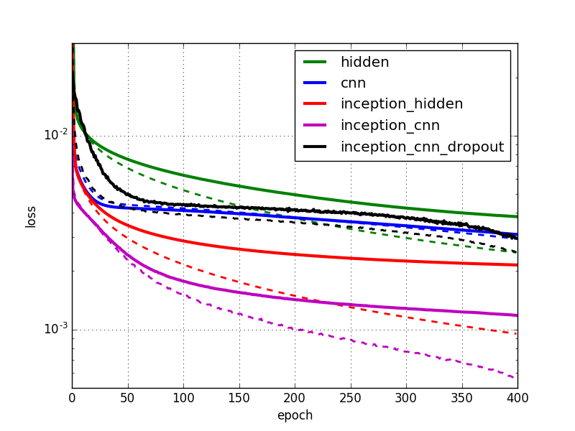
Figure 4. Regression loss (MSE) versus epochs

V.) To overcome overfitting, we use dropout as regularization
in the last Inception cnn dropout model. Even though the network is no longer overfitting, its performance drops dramatically to . However, from
the black curves in Fig. 4, we can see the trend of loss continuing decreasing as epochs increase. Since dropout makes the network converge slower, it needs more epochs to reach the same loss as the Inception CNN model.

Time Complexity :

Another important metric to evaluate the performance of a network model is its time cost in both training and testing. The results are shown in Table. 5, where training time represents the time cost for one epoch (1700 images) and testing time represents the time cost for predicting the keypoints in
one test image.For the basic hidden layer architecture, we can actually
verify the results theoretically. The original input is a 96×96=926 dimension vector, and the hidden layer size is 100. Hence the total amount of multiplication operations is around 106 (ignoring the impact from additions).
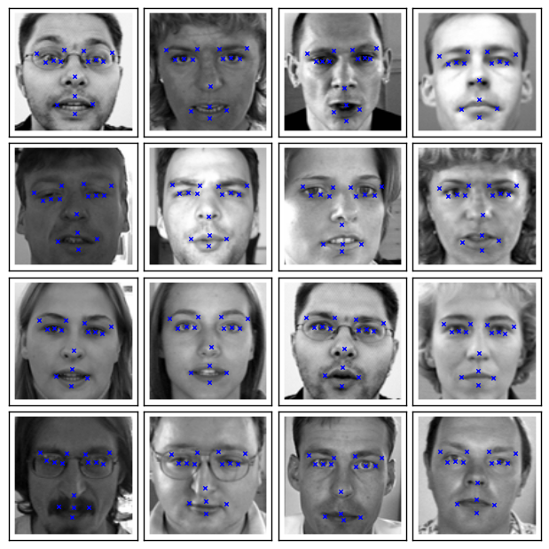
Figure 5. Key-points detection results

Using Inception features results in an dramatic increase in input
from 9216 to 28×28×256 = 200704. And we also increase the hidden layer size from 100 to 200. So the total number of multiplications is around 2×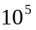×200 4×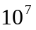.The amount of multiplications needs computing increases 40x, as a result of which, the time consumption should be
40x as well. Real numbers show 40.52(=12.155/0.30) and
45.62(=4.767/0.1045).
Convolutions are much more complicated due to matrix operation optimization in numpy. Linearly increased amount of multiplications may not cause linear increase in time cost. In our case, we use 28×28×256 rather than 96×96×1 as the input of Inception models. Even though
the actual computation amount rises dramatically, the actual time consumption drops in the training phase, and increases slightly in the test phase. In other words, bearing slightly higher time cost, the detection accuracy improves dramatically from 3.05 to 1.13.

 | Hid | CNN | Incp_hid | Incp_CNN | Incp_CNN_drpt
Train/s | 0.30 | 35 | 12 | 28 | 29
Test/ms | 0.105 | 7.67 | 4.77 | 8.50 | 8.86
Table 5. Time consumption in training and testing

References :

[1] M. Dantone, J. Gall, G. Fanelli, and L. Van Gool. Real-time facial feature detection using conditional regression forests. In Computer Vision and Pattern Recognition, 2012.

[2] M. Gargesha and S. Panchanathan. A hybrid technique for facial feature point detection. In Image Analysis and Interpretation, 2002. Proceedings. Fifth IEEE Southwest Symposium.

[3] M. Haavisto et al. Deep generative models for facial keypoints detection. 2013.

[4] E.-J. Holden and R. Owens. Automatic facial point detection. In Proc. Asian Conf. Computer Vision.

[5] B. Martinez, M. F. Valstar, X. Binefa, and M. Pantic. Local evidence aggregation for regression-based facial point detection. Pattern Analysis and Machine Intelligence, IEEE Transactions(2013).

[6] A. S. Mian, M. Bennamoun, and R. Owens. Keypoint detection and local feature matching for textured 3d face recognition. International Journal of Computer Vision.

[7] Y. Sun, X. Wang, and X. Tang. Deep convolutional network cascade for facial point detection. In Proceedings of the IEEE Conference on Computer Visionand Pattern Recognition.
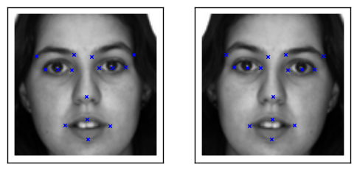
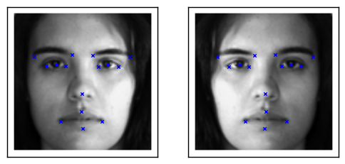

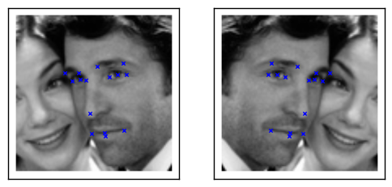

Toulik Das
B.tech CSCE
KIIT University

